

Die Welt Tour

Kinjalben Golaviya | 14.01.2021

# Kinjalben Golaviya - Schriftliches Konzept

1. Inhalt und Hauptidee einer Seite

* Personal website, both personal and professional
* For Travel Agency

1. Inhaltliche Strukturierung

* Long main page with animated Navigation bar and photos, short texts.
* Most Popular Tours By Company. (Pricing and offers)
* Customer feedback
* Some Pictures of Tour
* Travel details
* Contact us
* Footer with imprint, data protection things and cookie things.

1. Design

* Should be minimalist, natural tones and black and white as colors, font are used.
* flex (Flexbox) is used .
* Animation and JavaScript are used.

**Home Page**

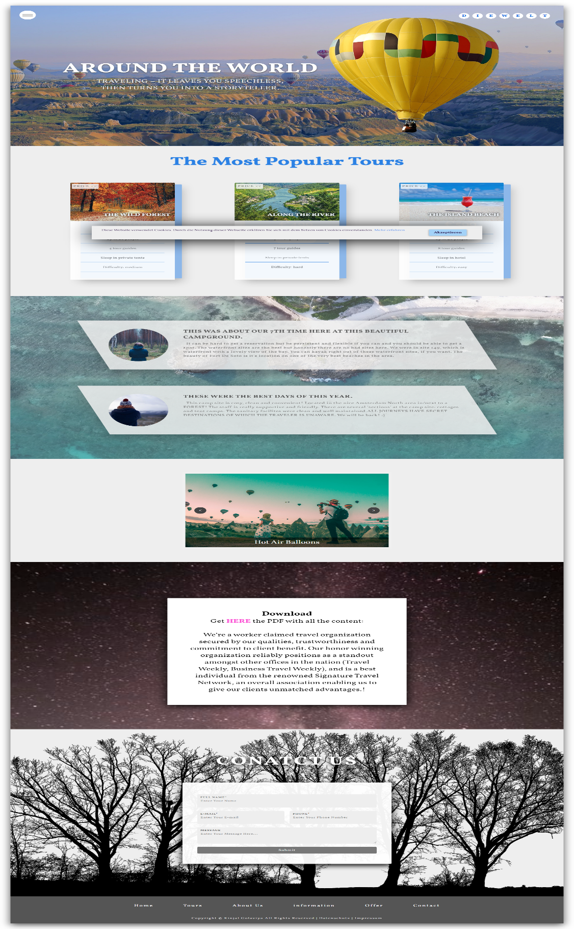

**Impressum**

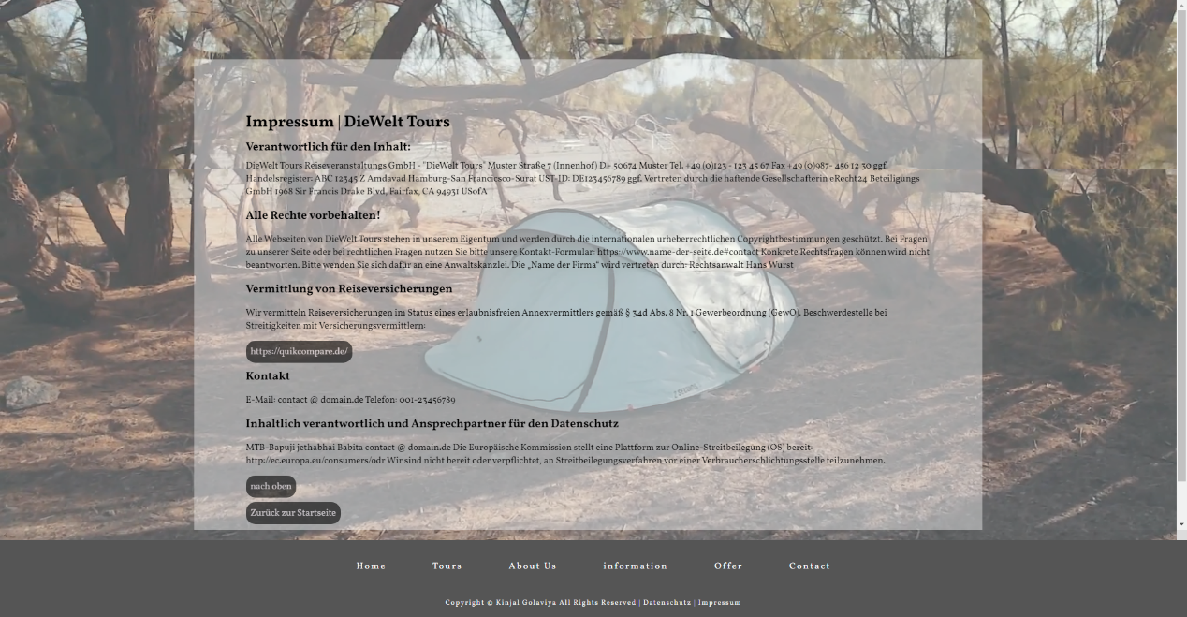

**DSGVO**

